Cambridge & Counties Bank Limited

Pillar 3 Disclosures

31 December 2023

Contents
Contents 2
1 Executive Summary 3
2 Introduction 4
3 Governance and Committees 6
4 Risk Management Objectives and Policies 10
5 Capital Resources 18
6 Remuneration 23

Executive Summary

Introduction
Cambridge & Counties Bank (CCB/ the Bank) is a UK bank that specialises in providing lending and deposit products for Small and Medium Enterprises (SMEs).

Established in June 2012, Cambridge & Counties Bank has a stable and supportive ownership structure being jointly owned by Trinity Hall, a college of the University of Cambridge, and Cambridgeshire County Council as Administering Authority of the Cambridgeshire Local Government Pension Fund.

The Bank is authorised by the Prudential Regulation Authority (PRA), regulated by the Financial Conduct Authority (FCA) and the PRA, and registered under the Financial Services Compensation Scheme.

The Bank does not have any subsidiaries.

Target Markets and Distribution Networks
Cambridge & Counties Bank provides lending products through a network of relationship managers who deal via business introducers as well as directly with customers. We seek to be straight forward and easy to deal with in our interactions with introducers and customers and deliver a banking experience that attracts and retains customers. The Bank delivers a range of savings accounts via the internet, post, and savings intermediaries.

We lend to experienced commercial and residential property investors as well as to owner occupied businesses to invest in their own commercial premises, secured on property. The Bank provides finance for businesses to acquire essential assets such as equipment, plant, machinery, or vehicles, using hire purchase and finance lease facilities. The Bank also provides finance for the purchase of classic cars using hire purchase and finance lease products.

The Bank remains focused on supporting SME customers in our chosen markets. As our customers reassess their investment priorities in a volatile and challenging economic climate and geopolitical environment, we continue to lend responsibly while also helping our customers navigate the challenges they face.

The Bank’s lending is primarily funded by the acquisition of UK savings balances. We offer a range of deposit accounts that are available directly to business customers. These accounts are also available to retail customers through a network of Deposit Intermediaries. Business customers include broader organisations such as charities, clubs, societies, and associations.

Financial performance
For the year ended 31 December 2023, the Bank had operating income of £76.4m (2022: £59.3m) and reported profit before tax of £40.9m (2022: £28.5m). Total equity as of 31 December 2023 was £215m (2022: £185m). The Bank employed an average of 225 FTE employees (2022: 206) during the year. Full details on the Bank’s financial results are reported in its statutory accounts which are published on its website ( https://ccbank.co.uk/about-us/annualresults/ ).

Introduction

Legislative Framework
CCB follows the Capital Requirements Directive (CRD) and Capital Requirements Regulation (CRR) requirements as on shored by the UK, effective 31-Dec-2020. These regulations lay down uniform rules concerning general prudential requirements that CRR firms in the United Kingdom shall comply.

CCB throughout this document has followed the Pillar 3 disclosure requirements as set out for CRR firms and complies with the requirements in accordance with Article 433c of the Disclosure section of the PRA Rulebook.

Basel Committee on Banking Supervision (BCBS)
Most of the global banking and insurance regulations have been initiated or inspired by the work of the Basel Committee on Banking Supervision and its so-called “Basel regulations”. The three pillars of this regulation are as follows:

Pillar 1
The first pillar focuses on the determination of minimum capital requirements to support exposures to credit risk, counterparty credit risk, credit valuation adjustment risk and operational risk. (See Section 5)

Pillar 2
Pillar 2 addresses risks not covered in the Pillar 1 framework. To calculate its Pillar 2 capital requirements the Bank has performed a detailed assessment of the risks facing the Bank including the impact of a severe economic downturn. The Bank has calculated the amount of capital that it considers necessary to cover these risks within its Internal Capital Adequacy Assessment Process (ICAAP). The Bank’s ICAAP is reviewed and assessed by the PRA during its Supervisory Review and Evaluation Process.

Pillar 3
Pillar 3 complements Pillar 1 and Pillar 2 and sets out the disclosures that banks are required to make in order to promote market discipline through the external disclosure of its governance, capital resources, risk management objectives, remuneration and risk exposures. The Bank is required to publish its Pillar 3 report annually.

Purpose

The Pillar 3 disclosures on capital and risk management of 31 December 2023, have two principal purposes:
- To provide information on the policies and approach taken by CCB to risk management and the maintenance of its capital resources, including details of:
- The governance structure of the Bank; and
- Detailed information concerning the Bank’s assets and capital resources.
- To meet the Pillar 3 regulatory disclosure requirements under the PRA rulebook effective 1st January 2023.

The Pillar 3 disclosures should be read in conjunction with the Annual Report and Financial Statements for the year ended December 2023, published on CCBs website.

Scope of Application
All the figures, governance, objectives, and policies included within this document are as of 31 December 2023 (unless stated otherwise) and have been prepared to meet the disclosure requirements under PRA Rulebook for CRR firms. The Pillar 3 report disclosures are issued on an annual basis and are based upon the Bank’s annual report and Financial Statements for the year ended 31 December 2023.

These disclosures have been reviewed by the Bank’s Audit Committee and approved by the Board. The disclosures are not subject to external audit, although some of the information within the disclosures also appears in the audited 2023 Financial Statements. The processes for preparing this disclosure are laid out in the Bank’s Pillar 3 Disclosures policy.

Publication
The disclosures are published on the Bank’s website: https://ccbank.co.uk/about-us/annualresults/

Regulatory changes
The regulatory landscape has remained relatively unchanged during 2023, with the next significant change expected with the implementation of Basel 3.1, effective 1 July 2025. The PRA has issued their near-final policy statements on Basel 3.1 – Part 1 and the Small Domestic Deposit Taker (SDDT).

CCB awaits the publication of the final Basel regulations in mid-2024 before completing its preparations for the change to the new framework.

Policy, Verification, Sign Off and Contact Details
The Bank’s Pillar 3 disclosures have been verified and approved through internal governance procedures in line with the Bank’s Pillar 3 Disclosure Policy. The Board reviewed and approved the disclosures in March 2024.

Cambridge & Counties Bank Limited
Charnwood Court
5B New Walk
Leicester
LE1 6TE

Telephone: 0344 225 3939
Email: Info@ccbank.co.uk
Web site: www.ccbank.co.uk

Governance and Committees

How the business is managed
Design and operation of a robust corporate governance framework is critical to meeting the needs of all the Bank’s stakeholders. The Bank has a well-established corporate governance structure, and the Board supports the principles of good corporate governance as set out in the UK Corporate Governance Code. Whilst the Bank is exempt from a number of the provisions due to it not being a listed entity, and its overall size in terms of employee numbers, it has reviewed the requirements and will ensure that its governance processes continue to follow best practice. The Board believe that its existing governance processes are appropriate for the current size and structure of the Bank.

Structure of the Board and Board Committees

The Board has overall responsibility for the operations of the Bank and is comprised of four independent Non-Executive Directors and two Non-Executive Directors representing the interests of the owners. The Non-Executives are currently complemented by three Executive Director (ED) board members – the Chief Executive Officer, the Chief Financial Officer, and the Chief Risk Officer. The Chief Development Officer retired on 31 January 2023 and his position has not been replaced on the Board.
The Board has its own terms of reference and has specific committees appointed by it for the purposes of Nominations & Governance, Audit, Risk & Compliance, Performance & Remuneration, and Executive Management. Each committee has its own terms of reference.
To ensure independence, and reduce the potential for conflict of interest, the sub-committees (excluding the Executive Committee) are each comprised entirely of Non-Executive Directors (NEDs), although individual EDs and others attend either as a matter of course or when requested to provide advice and guidance. A NED chairs each of the Board Committees except the Executive Committee which is chaired by the CEO.
CCB welcomed Michele Ibbs to the board as a Non–Executive Director and shareholder representative for the Cambridgeshire Local Government Pension Scheme and Elizabeth Lockwood joined us as a Non–Executive Director and Chair of our Risk & Compliance Committee. We said farewell to Christiane Wuillamie and Nick Treble, who previously held these respective positions.
Following the retirement of Simon Lindley, Chief Development Officer, and Sara Thorpe, Chief People Officer earlier in the year, we were delighted to welcome Sarah Barker, Chief Commercial Officer, and Lynsey Harrell, Chief People Officer, who joined the Bank’s Executive team mid-2023. Sarah will focus on sustainably growing Cambridge & Counties Bank’s real estate finance, asset finance, deposit, and marketing businesses to deliver enhanced dedicated solutions to our customer base. Lynsey brings deep experience in HR business partnering and project management, leading strategic people plans and transformational projects.

We are delighted with the skill set and competencies that Sarah and Lynsey bring; complementing the Executive with the expertise to help the Bank deliver on its strategic ambitions and achieving 40% female representation at senior management and 44% at Executive Committee levels.

With Elizabeth and Michele joining us, together with several appointments to the senior executive team, we have a complete refresh of the Board and the senior team, positioning the Bank well for the next stage of its development.

The diagram below sets out the Bank’s Committee structure:

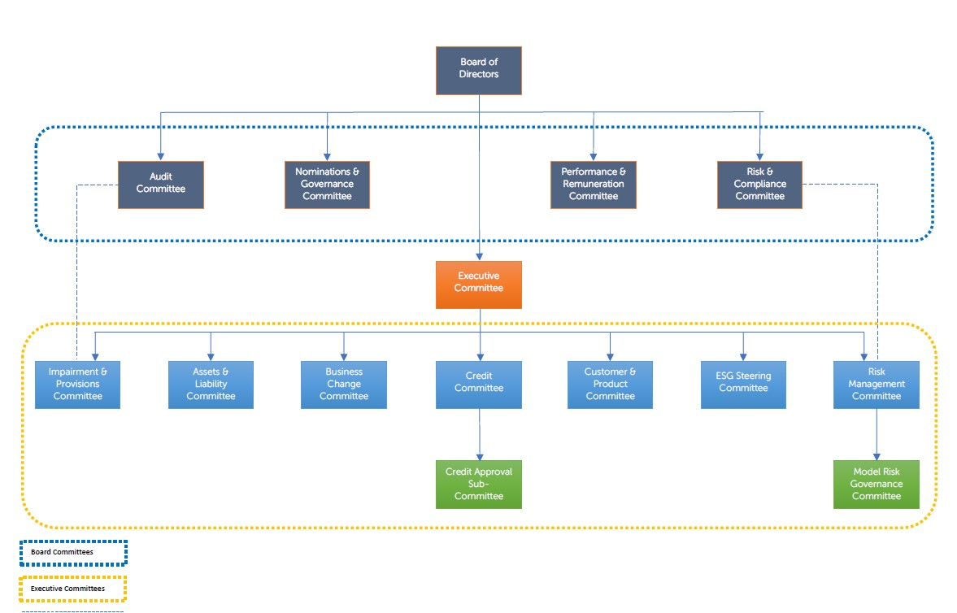

Information about the Bank’s recruitment approach, including diversity, can also be found on the Bank’s website (https://ccbank.co.uk/about-us/careers/).

Risk management is governed within the corporate governance structure, with ultimate ownership at Board level via the Risk & Compliance Committee. In addition, the Board Audit Committee facilitates third line review of all aspects of risk management and the Nominations & Governance and Performance & Remuneration Committees have a role in the management of conduct risk, including risk culture.

The table below sets out the Committee’s purpose and key responsibilities (as delegated by the Board) and Chairs. The Bank reviews the committee structure on an ongoing basis to ensure that it remains fit for purpose and maximises the effective decision-making ability of the Board.

Committee | Chair | Purpose / Responsibilities relating to Risk Management
Board | Patrick Newberry; Chair | - Ensuring the framework of prudent and effective controls and risk management are maintained;  - Review of the effectiveness of the risk and control processes to support the Bank’s strategy and objectives;  - Approval of regulatory documents including the Risk Appetites, ICAAP, ILAAP.
Audit | Mike Peck: NED | - Assisting the Board in carrying out their responsibilities relating to assuring the adequacy and effectiveness of the Bank’s overall financial governance, control framework and processes, including compliance with legal, regulatory, whistle-blowing, and financial reporting requirements;  - The appointment of internal and external audit and assessment of effectiveness.
Risk & Compliance | Elizabeth Lockwood; NED | - Providing oversight and advice to the Board in relation to current and potential future risk exposures of the Bank and future risk strategy, including determination of risk appetite and tolerance;  - Compliance with legal and regulatory requirements;  - Assisting on such other matters as may be referred to it by the Board;  - Promoting a risk awareness culture within the Bank;  - Providing oversight of the Bank’s risk and compliance functions and to receive and review reports on the Bank’s compliance (including Anti-Money Laundering) with financial services regulations.
Performance & Remuneration | Caroline Fawcett; NED | - Overseeing the establishment and implementation of a remuneration policy for employees and Directors, which is designed to support long term business strategy and values of the Bank, as well as promoting effective risk management and compliance with applicable legal and regulatory requirements;  - Reviewing performance and approval of remuneration arrangements as set out within its Terms of Reference.
Nominations & Governance | Patrick Newberry; Chair | - To consider and make recommendations in respect of appointments to the Board as well as the membership and chair of Board Committees;  - To monitor the governance arrangements of the Bank making recommendations to ensure that such arrangements are consistent with best corporate governance standards and to develop best practice.  - To oversee the fulfilment of Directors responsibilities under the SMCR,
Executive | Donald Kerr; Chief Executive Officer | - Implementation of the strategic objectives of the Bank in accordance with the Strategic Plan and compliance with the Company’s Budget and Risk Appetite;  - All day-to-day operational issues of the Bank which are delegated to the Business Management group;  - Reviewing draft Board papers and recommending for submission to Board;  - Approving the Terms of Reference and responsibilities of the Business Change Committee and the Customer & Product Committee and receive minutes from these committees;  - Ensuring all responsibilities are undertaken with due consideration given to the Bank’s Strategic Plan, Board approved policies and good customer outcomes.
Assets & Liability (ALCO) | Andrea Hodgson; Chief Financial Officer | - Control and stewardship of the Bank’s balance sheet risks and capital management in executing its chosen business strategy;  - Setting of limits in line with the Board’s risk appetite, monitoring exposures and implementing controls across the dimensions of capital, credit, funding and liquidity, and non-traded interest rate risk.
Risk Management | Mike Hudson; Chief Risk Officer | - To oversee and monitor the risks facing the Bank on a day-to-day basis;  - Specific responsibilities include operational risk, financial crime, conduct risk, operational resilience, legal risk, and regulation;  - Its key role is to provide the oversight, challenge, support and  advice necessary to embed and maintain a robust risk management culture  across the Bank;  - To ensure that the Bank maintains an appropriate risk management culture and an effective Risk Management Framework;  - To review the findings of Risk & Compliance reviews and monitoring the  remediation of outstanding action items;  - Oversight of the remediation of Internal Audit findings.
Credit | David Monks; Chief Lending Officer | - Manage and monitor the lending activities of the Bank on a day-to-day basis.  - Formulating the Bank's lending policies, overseeing the Bank's solicitor and valuation panels, and monitoring the Bank's large exposures. The committee are also responsible for agreeing the Bank's standard facility letters and terms;  - Monitor current and potential non-performing lending on an on-going basis, for the purpose of identifying and agreeing appropriate provisions for under-recoveries on those loans;  - Responsibility for the ongoing oversight and management of current and potential non-performing loans.
Customer & Product | Christian Cowie; Director of Marketing & Savings | - Oversight of customer outcomes that result from Bank’s operations, as well as the suite of products offered, including the product design, pricing, performance, and customer suitability.
Business Change | David Holton; Chief Transform-ation Officer | - To manage the effective delivery of the business change agenda including the people side of change;  - To prioritise the CCB Change Programme to align with business  priorities and ensuring delivery to agreed timescales, scope, budget, and available resources;  - To assess all new business investment cases and change requests,  ensuring that they are aligned with strategic business objectives and  tactical priorities;  - To ensure benefits realisation as a result of change investments;  - Assessment, approval, or recommendation of significant changes to inflight  Projects;  - Management of the overall risks of the CCB Change programme within  acceptable appetite, including people risks of change.
Impairment & Provisions | Andrea Hodgson; Chief Financial Officer | - The purpose of the Committee is to monitor current and potential non-performing lending on an on-going basis, for the purposes of identifying and agreeing appropriate provisions for under-recoveries on those loans;
Model Risk Governance | Mike Hudson; Chief Risk Officer | - Responsibility for the management and oversight of financial models used within the Bank.
Environmental, Social and Governance Steering | Richard Bryan; General Counsel | - To lead the Bank’s response to the risks, challenges and opportunities presented by factors influencing environmental, social and governance;  - The collection, management, and analysis of physical climate risk data to meet the changing expectations of society, investors, stakeholders, and the financial regulators.

Risk Management Objectives and Policies

Introduction
The Bank is committed to risk management. This is achieved through the maintenance of appropriate risk strategies, frameworks, organisational structures, and governance, plus embedding a strong risk culture embedded throughout the organisation.

The following chapter covers the key elements of the Bank’s approach to risk management. This includes how deterioration and/or non-compliance with appetite be detected, including consideration of the impact on capital requirements via the ICAAP process and liquidity requirements in the ILAAP.

Approach to risk, enterprise risk management framework and accountability

The Enterprise Risk Management Framework clearly articulates the Bank’s approach to risk management, the risks the Bank is willing to take, and the inherent risks, in pursuit of its strategy.

The framework ensures that from the top down there is effective identification, assessment, control, management, reporting and escalation of risk, to operate within the appetite set by the Board resulting in a transparent and strong risk culture. The key principles, tools, documentation, governance structure, roles, and responsibilities for risk management, across all risk categories, are confirmed in the framework along with the methodologies used to measure and monitor the ‘Risk Management Cycle’. In addition, the internal and external oversight, assurance, and approvals provided by Executive, Board, Second Line and Third Line control functions is confirmed.

A Risk and Control Self-Assessment programme and Top and Emerging risk reporting processes exist which supports monitoring and management of the Bank’s risk profile.

A forward-looking risk management approach is taken using quarterly stress testing and scenario analysis, feeding into the annual Internal Capital and Liquidity Adequacy Assessment processes (ICAAP and ILAAP) to ensure there is sufficient capital and liquidity to cover the risks to the Bank.

Governance of Risk Management

The Chief Risk Officer has operational responsibility for the management of the bank’s Enterprise-wide Risk Management Framework. The Board has responsibility for the setting of the firm’s Risk Appetite and approval of this framework, as well as ongoing oversight, principally through the Board Risk and Compliance Committee. The Bank’s corporate governance framework and committee structure is outlined in the corporate governance section.

Three lines of defence model
The Bank manages risk using the ‘three lines of defence’ model, via clear responsibilities established for all colleagues in relation to risk management, including Executive and Non-Executive responsibilities documented as applicable under the Senior Managers and Certification Regime. The model operates as follows:

Risk Appetite Introduction
The Risk Appetite articulates the amount and type of risks the Board is willing to take in pursuit of its strategy and objectives. The overall objective is to protect the Bank from unacceptable levels of risk while supporting and enabling overall business strategy (including the assessment of new business opportunities). The Bank’s Risk Appetite Statement outlines a mixture of qualitative and quantitative measures (Principal Risk Statements and Key Risk Indicators). The regular review of the Bank’s appetite for risk is facilitated and challenged by the Second line of Defence, driven by the recommendations of the appropriate executives and subject matter experts.

The Bank’s performance against Risk Appetite is monitored via reporting to the executive risk committees. This is summarised within the Chief Risk Officer Risk Management Report, which is presented to Risk Management Committee and appropriate Board committees monthly. The periodic reporting shows status against each Key Risk Indicator (KRI) and overall rating, based on parameters set within the Enterprise Risk Management Framework, using a Red/Amber/Yellow/Green (RAYG) scale and the expert judgement of the First and Second lines. These KRI’s detail the Bank’s Risk Appetite and are reviewed at least annually or in the event of a major change to strategy and/or environment within which the Bank operates. The Bank has adopted a tiered structure of risk indicators and metrics.

Level 1: They are considered as being the most fundamental measures of risk exposure. These are to be reported to the Board risk committee and its risk sub-committees on a monthly basis regardless of status
Level 2: Additional measures of risk exposure. These are to be reported to the relevant sub-committees on a monthly basis, and to Board Risk & Compliance Committee as/when they are reporting Amber or Red.
The risk profile is detailed in the below section.
Early Warning Indicators (EWIs)
Early Warning Indicators are measures that could be an indicator of potential future problems e.g. national or regional house prices. Internal EWIs are those that can be influenced directly or indirectly by the actions of the Executive and management. External EWIs are those indicators which reflect the prevailing economic and political climate. Although these external indicators are outside of the control of the Bank (e.g. UK Bank Base Rate) their prevailing level is the basis of assumptions within the Bank’s plans. The Board and the Executive are vigilant to unexpected movements or trends.

Risk Indicators and Metrics are monitored daily or monthly (as appropriate) by the Risk & Compliance Function. When the absolute value or trend predicts a potential issue, the necessary and appropriate actions are taken.

Risk Reporting
Regular Management Information packs are presented to the Risk & Compliance Committee and recommended to the Board ensuring that the management of risk is aligned to the Board’s risk appetites and that unacceptable risk exposures are identified and, where possible, mitigated at an early stage. The metrics provided are intended to facilitate:
- Backward-looking analysis to identify trends in risks and underlying drivers;
- Analysis of current Risk Indicators supported by risk reviews and risk event reporting;
- Forward-looking metrics that provide an early indication of potential threats to the Bank’s performance against Risk Appetite;
- Analysis of metrics is based on RAYG indicators that provide an early indication of potential stress and acts as triggers so that breaches of Risk Appetite can be avoided by adopting appropriate strategies and actions;
- Future trend analysis and calculation of rolling averages.
Management also receives daily reports to facilitate the ongoing assessment of performance against risk appetite including:
- the Daily Loans Dashboard, and,
- the Daily Liquidity Report.

The Risk Profile
The Bank’s principal risks are defined below along with their associated risk appetite statements:

- Strategic risk
The risk of having an insufficiently defined or flawed strategy that does not adapt to market and business developments and/or meet the requirements and expectations of our stakeholders. The Bank maintains a low appetite for Strategic Risk.

We aim to deliver a satisfactory return on capital to our shareholders, generating profitable returns and building gross lending balances, whilst retaining stable asset quality and maintaining a satisfactory cost of risk. We will achieve this within our stated Risk Appetite and regulatory guidelines and deliver market leading customer service, demonstrated by above average new business margins and positive customer experience. We aim to be an employer of choice, ensuring that we have the right mix of skills and experience to grow the Bank. We work hard to protect our brand, minimising reputational risk and play an active and responsible part in our community.

- Environmental, Social and Governance Risk
The risk that, if an environmental social or governance event occurs, it could cause an actual or a potential material negative impact on the Bank. The Bank will achieve this within its stated Risk Appetite and regulatory guidelines and deliver positive ESG behaviours whilst managing any potential conflicts of interest, such as the prevention of greenwashing.

Environmental: The Bank has a low appetite for Environmental Risk overall. We proactively manage the Loan Book to minimise the physical and transitional risks to the Bank from climate change. The Bank is actively trying to avoid the creation of ‘stranded assets,’ i.e., those assets that become difficult to rent or sell due to either their energy performance rating or flood risk, which in turn may impact the value of the security

Social: The Bank has a low appetite for Social Risk overall and aims to create a positive impact on the local community and to be an employer of choice for its colleagues. We demonstrate positive inclusive and diverse behaviours to create and maintain a workplace that attracts, retains and rewards talented and committed people, who feel a belonging to the firm. Additionally, we engage in the local community through a mix of sponsorship and volunteering.

Governance: The Bank has a low appetite for Governance Risk overall and aims to deliver the strategic plan set by the Board whilst adhering to the guidelines established by the Task Force on Climate-related Financial Disclosures.

In April 2023, the Bank made a constitutional change to complete the ‘Mission Lock’ required as part of becoming a B Corp. The aim of Mission Lock is to allow the Board to promote the success of the Company through its business to have a material positive impact on society and the environment, as well as for the success of its shareholders. The Bank’s status as a certified B Corp provides a governance framework for the Bank to manage ESG impact. The Bank believes that being a B Corp aligns with its vision of building a more inclusive, equitable and regenerative economy for all people and the planet.

- Capital Adequacy risk
The risk that the Bank fails to hold sufficient capital to meet its regulatory obligations, support its growth plans or to absorb shocks. The Bank maintains a low appetite for Capital Adequacy Risk.

Our priority is to maintain (via retained earnings) a capital surplus above CET1 and Total Capital Requirements sufficient to absorb any unexpected losses and costs without using regulatory buffers, noting the position may change in times of significant macro-economic stress. An initial evaluation of the potential impact of Basel 3.1 on the Bank’s risk weighted assets and capital requirements has been completed.

- Liquidity and Funding risk
The risk of being unable to fund assets and meet obligations as they fall due without incurring unacceptable losses. The Bank maintains a low-risk appetite for Liquidity & Funding Risk.

The Bank monitors its liquidity and funding requirements on a regular basis, including intra-day risk and maintains sufficient liquidity headroom to ensure that the Board’s risk appetite and regulatory requirements are always met. We will maintain sufficient liquid assets to meet liabilities as they fall due in a stressed scenario, including satisfactory liquidity coverage and loan to deposit ratios. We will ensure that we are not overly reliant upon any single savings intermediary to raise deposits and continue to grow deposits raised directly from customers.

- Market risk
The risk that changes in market rates negatively impact the earnings or market value of the Bank’s assets or liabilities. The Bank has no appetite for foreign currency risk and a low appetite for interest rate and basis risk.

Market risk is limited to Interest rate risk in the Banking Book. The Bank maintains its assets, liabilities and off-balance sheet exposures in Sterling are carefully manages mismatches between tenors of loans and deposits, hedging exposures where necessary within pre-determined limits

- Credit risk
The risk that counterparties fail to meet the commitments into which they have entered in a timely manner. The Bank has a moderate appetite for Credit Risk overall, maintaining conservative parameters including a maximum LTV and minimum DSCR, as well as focusing on relationship management, including annual reviews. Credit risk represents a principal risk for the Bank.

We will maintain the Bank’s lending distribution and product offering within parameters agreed by the Board, diversified by sector and UK region, with a minimal appetite for ‘speculative’ lending. These ensure that we concentrate lending on areas where we have experienced subject matter experts both in the First and Second line of defence, with the necessary operational capacity, systems, and infrastructure to effectively manage and monitor the loans through their life cycle. We will operate within protocols, underwriting guidelines, exception limits and regulatory guidelines and manage the Early Warning Report and Watch List proactively to ensure that asset quality remains satisfactory. Although we recognise that through the full economic cycle, some credit losses are inevitable, our robust underwriting standards aim to minimise them, with close monitoring of risk appetite monthly via the comprehensive suite of KRIs. The Bank assesses and discusses all individual customer loans in arrears at the monthly Impairment and Provisions Committee chaired by the CFO.

The Bank continues to assess the potential impact of climate change and the environmental factors across its loan portfolio as well as undertaking appropriate stress testing.

- Legal, Compliance & Regulatory
The risk that non-compliance with laws or regulations could give rise to fines, litigation, sanctions, reputational damage, or financial loss. The Bank maintains a low appetite for Legal, Compliance and Regulatory Risk.

Whilst the Bank recognises that operational errors can occur, it maintains zero tolerance for breaches of regulations, relevant legislation, late responses to regulatory requests or gifts/hospitality policy breaches. We strive to ensure that we always remain within the law and regulation. Regulatory Changes are logged, allocated, monitored, and tracked on a dedicated Horizon Scanning log ensuring additions to or changes within regulatory requirements are proportionately applied. All material breaches are investigated and reported to the Risk & Compliance Committee in a timely manner, rule changes are implemented within the applicable regulatory timelines and staff operate within the Bank’s documented policies and controls and, where applicable, industry guidelines.
- Financial crime
The risk that inadequate controls relating to financial crime could give rise to fines, litigation, sanctions, reputational damage, or financial loss. The Bank maintains a low appetite for Financial Crime risk, aiming to maintain a low level of residual risk and striving to ensure that we always remain within the law and regulation.

Whilst we recognise that operational errors can occur, we maintain zero tolerance for breaches of compliance with applicable financial crime laws and regulations, deliberate facilitation of tax evasion, bribery and facilitation payments and internal fraud. All material breaches are investigated and reported to the Risk & Compliance Committee in a timely manner, rule changes are implemented within the applicable regulatory timelines and staff operate within documented policies and controls and, where applicable, industry guidelines.

- Operational risk
The risk that events arising from inadequate or internal process failure, people, and systems or from external events cause regulatory censure, reputational damage, financial loss, service disruption and/or customer detriment. The Bank maintains a low appetite for Operational Risk. Operational Resilience metrics are included within Operational Risk reporting.

Operational Risk related losses have historically been low, the framework has been strengthened following an external review and ongoing enhancements are being undertaken to ensure that the Bank’s Operational Risk Framework is in line with its regulatory requirements and leading practices. This includes continuing to work closely with our external technology providers to ensure ongoing operational resilience.

We aim to minimise incidents and losses arising from operational risk issues by maintaining a resilient infrastructure, including robust systems, employing and training the right people, minimising the impact of external events, and having a framework in place to ensure operational risks are captured, monitored, and mitigated, with lessons learned. This includes clear First line ownership of operational risks, review, and challenge by the Second line and assurance from the Third line. Focus is maintained on key risks, including outsourcing, operational resilience, people, cyber and technology risks, noting that the Bank has a lower appetite for risks associated with material outsourcing and critical non-outsourcing arrangements. We will ensure that our systems and operational capabilities are stable and resilient, with preventative measures in place to reduce the risk of service disruptions, and effective business continuity and disaster recovery plans maintained to limit the impact of disruption events. A suite of KRIs enable escalation of issues to senior management and the Board, periodic reviews are undertaken via Risk and Control Self Assessments and Operational Risk Events are captured, recorded, reviewed, and reported on, with root cause identified, trends reviewed, and actions taken to avoid recurrence.

Maintaining Operational resilience is a key regulatory and operational requirement to ensure the Bank can prevent, respond to, recover, and learn from operational disruptions. As several key IT services are outsourced, including the Bank’s core platform, satisfactory performance of its service providers is an ongoing part of ensuring continued Operational Resilience. The Bank completes annual testing of its Important Business Services and continues to complete the required review cycle all of which is Board approved. Resiliency is also tested via IT disaster recovery, crisis management planning (both desktop & simulated scenario) and business continuity. Our third party’s resiliency forms part of the Bank’s internal testing.

- Conduct risk
The risk that customers suffer loss or detriment due to failures at any stage of the customer journey, including inadequate product design, sales/marketing processes and operational delivery, data management and record keeping or the failure of its staff or key providers of services, to act with integrity and treat the customers’ best interests as the highest priority. The Bank maintains a low appetite for Conduct Risk.

We employ a strategy that is customer-centric, transparent, and built on integrity, professionalism, and fairness, ensuring that all our employees understand and fully operate within regulatory requirements (including the FCA Conduct Rules and Consumer Duty requirements). Furthermore the Bank’s Strategic Priorities (including ‘maintaining a culture of ‘doing the right thing’ for our customers and staff’ and ‘delivering clear and simple products’) ensure all staff take responsibility for proactively managing Conduct Risk, maintaining customer interests as the highest priority. The Bank prides itself on its strong risk culture and focus on customer outcomes. A Conduct Risk Framework is in place to ensure continued compliance with all requirements in this regard, including detailed reporting to the risk committees.

- Financial models
The risk that the Bank incurs financial loss because of decisions that are principally based on the output of (internal) models, due to errors in the development, implementation, or use of such models. The Bank maintains a low appetite for Model Risk.

We aim to minimise incidents and losses arising from model risk issues by maintaining and operating within an appropriate governance framework, supported by a governance policy. We have a clear definition of a model and maintain an inventory of all models within the Bank. We adopt a proportionate risk-based approach according to the materiality of each model, with specific requirements regarding model development, independent validation, approval, implementation, monitoring and recommended enhancements and future developments. Oversight is provided by the Second line of Defence and the quarterly Model Risk Governance Committee.

Additional disclosures on the risk profile and key mitigants are contained in the 2023 Annual Report and Financial Statements.

Emerging Risks and Uncertainties
On a regular basis, the Bank will reassess the key risks to which it is exposed and add any which are emerging via the environment in which it operates. The emerging Risks during 2023 and at the time of the preparation of this document are assessed to be:
Emerging Risk | Definition | The Bank’s Response
Global macro-economic outlook | The current geopolitical events in the world, including several international conflicts and the elections in the UK and US later in 2024, continue to cause ongoing uncertainties. Additionally, these conflicts could lead to increased commodity and supply costs, as well as supply-chain disruption, which could cause additional economic headwinds for the UK economy, noting that UK interest rates remain high compared to recent times. | The Bank monitors a range of current and forward-looking measures covering all risk types (primarily operational, conduct, strategic, and credit). These are reviewed by management and oversight forums on an ongoing basis, and appropriate responsive action undertaken. In mitigation to more severe scenarios, documented arrangements are in place for each of the Bank’s Important Business Services, and for each business area, identifying key points of failure and management’s contingency arrangements.
UK macro-economic Risk | The geopolitical events and other economic challenges, such as cost of living/inflationary pressures, continued higher interest rates and reduced levels of investment continue. There remains some risk of ongoing economic uncertainties, impacting the Bank and its customer base, resulting in the potential for the Bank being unable to achieve its business targets – both growth as well as increased credit risk, as borrowers see increased debt servicing costs. | Macroeconomic risk is considered as part of the Strategic Planning process and monitored via reporting to Board and Executive level committees. The Bank continues to support its customers and develop its lending policy to ensure it remains appropriate to changing circumstances. The Bank has recently joined the Lending Standards Board.
Delivery of the 2024+ Growth Plan | The risk that pursuing the business growth targets outlined in the most recent Strategic Plan will bring additional operational pressures and create increased risk, either Credit Risk or Operational/Fulfilment Risk. | The Bank made significant investment in process capability during 2023 and continues to monitor external events to ensure its credit policy remains appropriate. Regular reporting of Key Risk Indicators is provided to both management and the Board, to ensure it remains within Risk Appetite using its Risk Management Framework. Significant resource is dedicated to operational management and oversight. Resource planning helps the Bank ensure it recruits sufficient resources/skills to manage the risk and quarterly reforecasting is undertaken.
Climate Change | Climate Change is a growing risk and ongoing consideration needs to be given to the longer-term impacts, particularly in relation to the loan portfolio. If left unchecked, it could lead to a medium/long term risk to the credit quality of the book because of extreme climate events such as flood risk and poor preparedness and lack of attention given to this risk by the property industry (which continues to tolerate low EPC grades) and impact on the Asset Finance and Classic Vintage and Sports car loan (CV&S) books. Both physical and transitional risks are being factored into Risk Appetite, Key Risk Indicators, and broader lending activity. | This is a topic that the Bank takes very seriously and has conducted a detailed report in response to the PRA’s Climate Change Requirements and plans for firms to manage these risks. The Environmental, Social & Governance (ESG) Steering Committee, chaired by the Banks General Counsel and supported by the Chief Risk Officer, continues to develop the Bank’s action plans, in addition to working with external bodies, such as UK Finance, to assess sector preparedness, planning and actions to ensure the Bank’s initiatives remain appropriate and relevant. Regular progress reports are provided to key stakeholders, including the Board.
Cyber Threat | The nature of cyber attacks across the industry continues to change with the use of more sophisticated unseen malware methods, as well as increased volumes.  CCB’s operations are inherently reliant upon its technology infrastructure, and the performance of third-party technology firms to maintain cyber security defences. | CCB’s technology infrastructure is UK based and has a very small externally facing footprint. The Bank’s websites are outside its perimeter, reducing the inherent exposure. Furthermore, the Bank profile, suppliers, and customer-base does not make it an obvious target for state-sponsored hackers and other hackers.  The Bank’s technology perimeter has been reviewed without issue, and patching timescales are as aggressive as possible. Technology arrangements have been reviewed against the NCSC guidance, and no deficiencies or areas for improvement were identified.  A Cyber Strategy and linked programme of focused work, including obtaining a NIST Level 3 status, has begun and will continue throughout 2023 which includes strengthening both Board and colleagues understanding and ownership of cyber risk and the actions they need to take. Board and Executive cyber and information security-based training has been provided in 2023.
Legal, Compliance & Regulatory. | The UK has an extensive regulatory environment which applies to all UK firms. Proposed regulation relating to a Strong and Simple Regime along with Basel 3.1, is expected to have an impact on the Bank, including its capital holding requirements. | The Bank has a dedicated Compliance, Prudential Risk and Legal Function along with a dedicated horizon scanning process which monitors regulations to help inform management of any changes. The Bank also engages with the relevant trade bodies and other industry professionals to help ensure that it meets its legal and regulatory requirements. Where appropriate, management also contribute to various regulatory consultations, as part of a wider industry response to proposed regulatory changes.

The Bank does not consider settlement risk, group risk, pension risk and wrong way risk as applicable to its business model and operations. Additional disclosures on Risk management and the framework are included in the 2023 Annual Report and Financial Statements.

Capital Resources

Available Capital Resources
CCB manages its capital requirements in accordance with the PRA Rulebook for CRR firms. The Bank’s policy is to maintain a strong capital base to maintain investor and market confidence and to sustain the future development of the business. Throughout the period to 31 December 2023, the Bank maintained its capital resources at a level above the minimum capital adequacy requirements.
The Board manages its capital levels for both current and future activities and documents its risk appetite and capital requirements during stress scenarios as part of the ICAAP. The Bank presents regular reports on the current and forecast level of capital to the Executive Committee, ALCO, Risk & Compliance Committee and to the Board.
The Bank has elected to use the Standardised Approach for credit risk and the Basic Indicator Approach to operational risk. The Bank is not exposed to Market Risk.
Under PRA Rulebook, the Bank must set aside capital equal to 8% of its total risk weighted assets to cover its ‘Pillar 1’ capital requirements. The Bank must also set aside ‘Pillar 2’ capital to provide for additional risks. The ICAAP is the Bank’s internal assessment of its Pillar 2 capital requirements, which the PRA reviews and advises its expectations of the level of Pillar 2 capital to be held. The PRA will set Pillar 2A requirements for risks not captured under Pillar 1 capital requirements and it will set Pillar 2B requirements to meet potential shortfalls in capital that may occur in the future due to severe stress scenarios like economic downturns. Pillar 1 and Pillar 2A requirements are referred to as the Bank’s Total Capital Requirement (TCR). CCB maintains its capital base in excess of its TCR and PRA Buffer and has complied with all externally imposed capital requirements during 2023. The PRA monitors capital adequacy through regulatory returns.
In addition to the TCR and PRA Buffer requirements, the Bank holds capital to meet the Capital Conservation Buffer (CCoB) and Countercyclical Capital Buffer (CCyB).
Under the Bank Recovery and Resolution Directive (BRRD I and II), the Bank of England has assigned CCB to the ‘Modified Insolvency’ category. The Bank meets this requirement by holding sufficient capital to meet its Total Capital Requirements (TCR) which comprises Pillar 1 and Pillar 2A.

Key metrics
The table below presents CCBs key metric positions using its audited accounts as at 31 December 2023, with only items applicable to the Bank being shown.
As at 31 December 2023, the Bank maintained a strong regulatory capital position of £219m (2022: £186m).
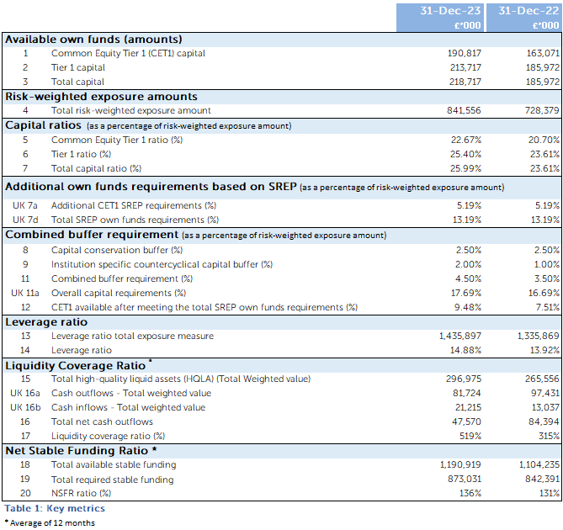

Overview of risk weighted exposures
The assets of the Bank are analysed by risk category and are assigned weightings which reflect the level of risk exposure under the Standardised Approach. The Bank’s credit risk consists of counterparty credit risk and all other credit risk, principally arising from its loans and advances to customers. The Bank’s minimum capital requirements for credit risk are calculated by applying the Pillar 1 capital requirement of 8% to the risk weighted assets of CCB. Credit risk weightings are determined by the Standardised Approach as set out in the CRR. The Bank uses Moody’s Investors Service as its nominated External Credit Assessment Institution (ECAI) for all standardised counterparty credit risk exposure classes. The Bank holds derivative instruments to manage its minimal interest rate risk and does not hold a trading book. Derivatives follow the original exposure method for credit risk.

CCB is subject to Pillar 1 capital requirements related to the following risk items:
- credit risk
- operational risk;
- credit valuation adjustment risk;
- counterparty credit risk;
- prudent valuation on fair valued assets.
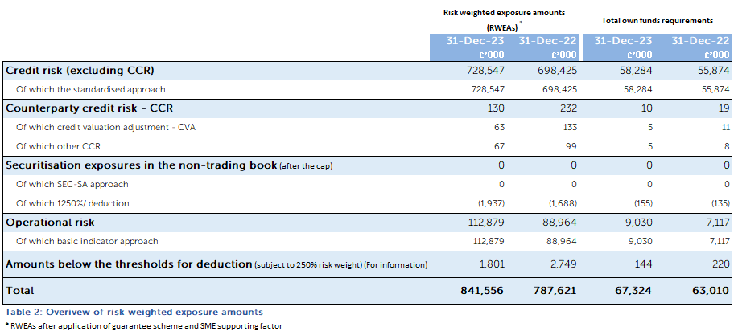

Credit risk exposure comprises of the following exposure classes for 31-Dec-2023 along with their exposure values and risk weighted exposures.

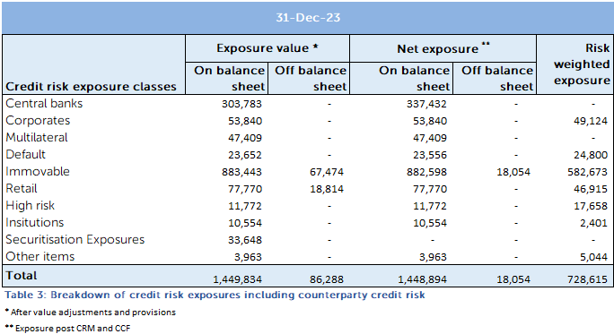

Composition of regulatory own funds
CCB holds CET1 capital consisting of Share capital and retained reserves. The regulatory CET1 capital is stated in the table after regulatory adjustments. The Bank also holds perpetual convertible loan notes eligible for AT1 and subordinated debt Tier 2 capital.

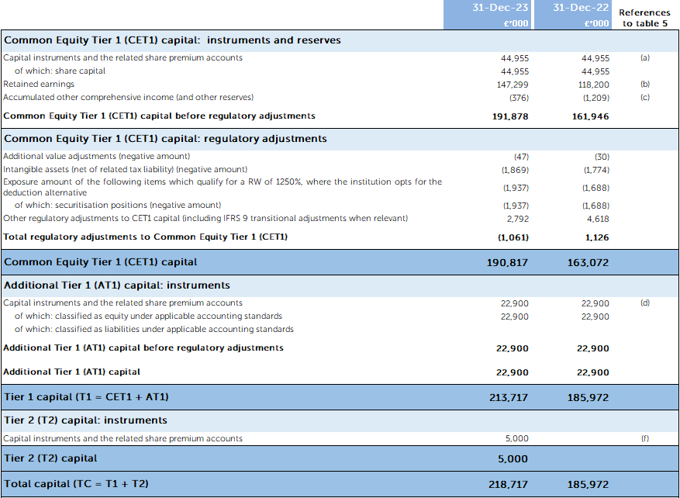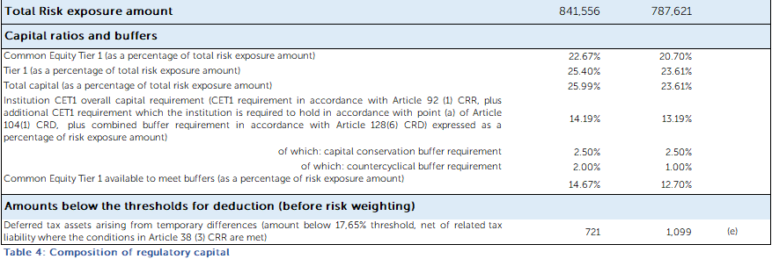

Reconciliation of Regulatory own funds to balance sheet in the audited Financial Statements
The following table shows comparison of items reported on the Banks Financial Statements and their corresponding scope for prudential regulatory reporting.

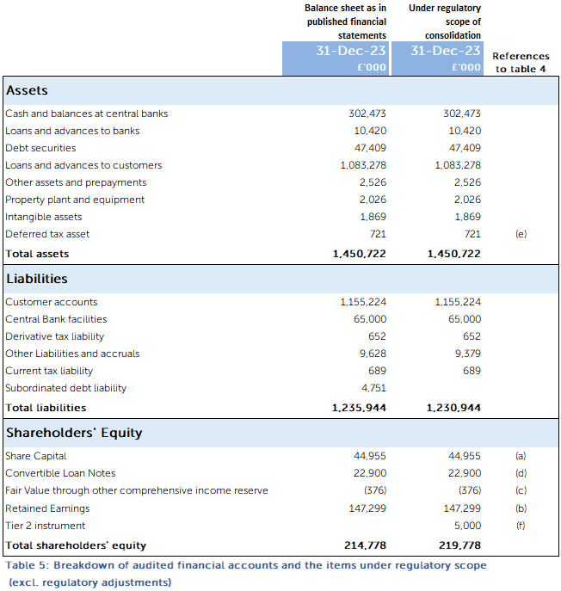

A reconciliation between Shareholders equity and Regulatory capital is shown below. The regulatory capital post adjustments are detailed in table 4.

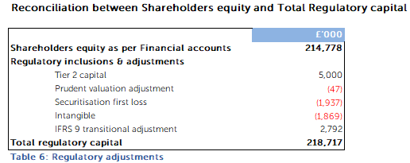

Remuneration
The Bank is classified as a “Proportionality Level 3” firm for the purposes of the disclosure of remuneration under the Bank of England Supervisory Statement SS2/17 and in compliance with the CRR on Remuneration Disclosure. The Bank has followed the regulator’s guidance on materiality and proportionality. The following disclosures meet the requirements for a Level 3 proportionality firm.
The Performance and Remuneration committee is chaired by Caroline Fawcett, Senior Independent Non-Executive Director, and is composed entirely of NEDs and met five times during 2023. In these meetings, the committee, in carrying out its responsibility for overseeing the performance and remuneration arrangements of the Bank, discussed the performance of all Executive Directors and the Chair.
During the year, the Committee reviewed and, where felt appropriate, approved the Bank’s profit share scheme and the sales and executive bonus schemes, upon agreed metrics and performance criteria, as well as upon advice from the Bank’s auditors and risk function. It also oversighted the annual pay review. The Committee has followed the rules under the Remuneration section of the PRA Rulebook.

Remuneration policy

Purpose & Objective
This policy describes the approach taken by Cambridge & Counties Bank in relation to its management of remuneration and describes how it complies with the relevant requirements of the Financial Conduct Authority (FCA) remuneration code (SYSC 19D) and the Prudential Regulation Authority (PRA) rulebook.

The Board of Cambridge & Counties Bank is committed to ensuring that the Bank has risk-focused remuneration policies, which are consistent with and promote effective risk management and do not expose the Bank to excessive risk.

The purpose of this Remuneration Policy is to clearly document the policies, practices and procedures linked to salary, compensation, and reward of employees. It is reviewed and approved annually by the Performance & Remuneration Committee.

Policy Scope
The policy relates to the remuneration of all employees; it covers both fixed (non-variable) and variable elements of pay and reward. Fixed elements are defined as salary, and allowances paid as a result of contractual obligations (e.g. car allowance, holiday pay, medical insurance, pension, and death in service). Variable elements consist of schemes designed to reward performance at both the corporate, team and individual level (e.g. Profit share, performance bonus schemes).

Specific remuneration rules may apply to board members and employees, who, because of their function, may have a material impact on the risk profile of the Bank, collectively referred to as “Material Risk Takers”.
The policy also covers fees paid to Non-Executive Directors.

The policy is to:
- Attract, develop, and retain high performing people with the ability, experience, and skill to deliver the business strategy and objectives;
- Offer competitive and market aligned remuneration packages in which fixed salaries are the significant component;
- Encourage and incentivise employees to create sustainable results, which are consistent with strategic goals and appropriate risk management, and align the interests of the Bank’s shareholders, customers, employees, and other key stakeholders; and
- Drive behaviour consistent with the Bank’s values so that employees do what is right for the customer, for colleagues, the Bank, and other stakeholders.
The remuneration policy and structure are consistent with the Bank’s long-term strategy including the overall business strategy, the risk strategy, and the Board’s risk appetite across all types of risk including credit, market, operational, capital and liquidity, reputational and other risks identified by the Bank. This is achieved through the application of the following six principles which are adhered to when designing or implementing any aspect of remuneration:
- We offer a competitive total reward package that is designed to be motivating and compelling and is regularly reviewed against market rates;
- Reward is linked to employees’ behaviours and values as well as achievement: the ‘how’ as well as the ‘what’;
- Our remuneration structures are straightforward; as such they are transparent, communicated and understood by all employees and all our stakeholders;
- There is a clear link between business, team and individual performance and reward, and people can explain when and why adjustments for performance have been applied;
- Our remuneration practices are consistent with and promote sound and effective risk management and are fully compliant with all appropriate governance, regulatory requirements, and codes of practice; and
- Our remuneration policies, packages and processes are designed to be affordable, consistent, and efficient, and do not limit the Bank’s ability to strengthen its capital base.

Governance
The Board of Directors has established a Performance & Remuneration Committee, which:
- exercises independent judgment on remuneration policies, practices, and recommendations of the Executive;
- ensures compliance with this policy, regulations, and statutory duties;
- advises on remuneration policies and practices generally;
- provides specific recommendations on remuneration packages and other terms of employment for Executive Directors; and
- considers the implications of remuneration policy and practices on management risk, capital and liquidity.

The Performance & Remuneration Committee is made up of Non-Executive Directors and shareholder representatives. The Chief Executive Officer, Chief People Officer and General Counsel are attendees. The full description of the Committee’s composition, tasks and authority are available in its Terms of Reference.

It is inbuilt to the remuneration review process that the Bank’s Risk and Compliance function is able to provide challenge to bonus and incentive payments where it feels individuals may be rewarded for poor risk behaviours; this is achieved through the Chief Risk Officer’s (CRO) report to the Performance & Remuneration Committee, inclusion of the CRO in calibration and approval meetings, and the membership of the Chair of Risk on the Performance & Remuneration Committee.

Malus and Clawback
Malus means the reduction and /or cancellation of unpaid, unvested, or unsettled variable amounts of remuneration when a Trigger Event is discovered, and the Board seeks to fulfil its fiduciary duty to shareholders by invoking its discretion to reduce and/or cancel a variable remuneration amount.

Clawback means when incentive remuneration has already vested, been settled, paid, or otherwise made available, and a Trigger Event occurs which indicates an error in the calculation of an individual’s remuneration, and the Board seeks to fulfil its fiduciary duty to shareholders by invoking its discretion to recoup all or part of a variable remuneration amount.

Roles & Responsibilities
The Chief People Officer is responsible for the maintenance of this policy and ensures that Risk & Compliance Committee is made aware of any changes to enable the policy review schedule to be updated.

Reward outcomes in 2023
The Performance & Remuneration Committee has reviewed the business performance in 2023 and considered risk events in conjunction with the Board Risk & Compliance Committee, the affordability of paying variable pay, and the associated risk of low variable pay. After assessment of performance, the Committee has approved distribution of £2.8m variable pay award for 2023 (2022: £2.5m).

Executive Director Remuneration
The table below summarise the Executive Directors’ remuneration policy for 2023:
Element of Remuneration | Purpose and Link to Strategy | Operation | Maximum | Performance Targets
Salary | - The Performance & Remuneration Committee is committed to adhering to the Financial Services Remuneration Code, thus ensuring that the Bank has risk-focused remuneration policies  - Reflects skills and experience over time  - Reflects the value of the individual and their role  - Provides an appropriate level of basic fixed income  - Avoids excessive risk taking from over reliance on variable income | - Reviewed annually  - Takes periodic account of practices of financial institutions of similar size, characteristics, and sector comparators | - There is no prescribed maximum annual increase.  The Performance & Remuneration Committee is guided by the general increase for the broader employee population and on occasions may need to recognise, for example, an increase in the scale, scope, or responsibility of a role. | - An element of performance-related pay applies
Benefits | - To aid retention and recruitment | - Company car allowance, provision of private medical insurance, life assurance and permanent health insurance | - Not applicable | - Not applicable
Pension | - Provides retirement benefits  - Opportunity for executives to contribute to their own retirement plan | - Defined contribution | - Bank contribute 10% of salary provided executives contribute a min 3% of salary.  - Executives may request a salary sacrifice for the equivalent of their personal pension contribution. This arrangement is also available for other staff.  - For EDs who have exceeded their lifetime allowance and/ or tapered allowance, there is the option of taking a 10% pension allowance in cash (taxable allowance). | - Not applicable
Bonus | - Incentivises annual delivery of financial and strategic goals  - Maximum bonus only payable for achieving business and personal targets | - Paid in cash  - Not pensionable  - Recovery provisions apply in line with the Bank’s Remuneration Policy | - Fifty percent of salary | - A combination of 50% company and 50% individual performance measures  with a deferred element of amounts over 20% of salary paid over 3 years
The choice of the performance metrics applicable to the annual bonus scheme reflects the Board’s belief that any incentive compensation should be appropriately challenging and tied to the delivery of the defined financial and risk management objectives, along with specific individual objectives. An element of deferral applies to the executive directors’ bonus scheme.
Benefits offered to Executive Directors apply from the commencement of employment.

Consideration by the Directors of matters relating to Directors’ Remuneration

The Performance & Remuneration Committee engage Deloitte LLP (Deloitte) to provide independent advice on remuneration matters. Deloitte is a member of the Remuneration Consultants Group and, as such, voluntarily operates under the code of conduct in relation to executive remuneration consulting in the UK. Deloitte has provided independent advice on matters under consideration by the Performance & Remuneration Committee including compliance with regulations, advice on market trends and data, remuneration policy and implementation of remuneration arrangements, including support in remuneration arrangements for departing Executives. The Performance & Remuneration Committee is satisfied that the advice it has received has been objective and independent.

The total remuneration paid to the Bank’s highest paid Director for qualifying services as a director in the period from 1 January to 31 December 2023 is included in Note 11 to the Financial Statements.

Remuneration policy for other employees

The Bank’s approach to annual salary reviews is consistent across the business with consideration given to affordability, the level of experience, responsibility, individual performance, and salary level in comparable companies.

Pension and benefits provided to all employees are broadly in line with the policy for Executive Directors, although the commencement of benefits may be subject to longer periods of eligibility at the start of employment.

Remuneration policy for Non-Executive Directors

All Non-Executive Directors are appointed for an initial term of 36 months and may be terminated by either party upon 3 months’ written notice. Non-Executive fees are set in line with the policy in the table below. Non-Executive Directors are not eligible to participate in any of the benefits provided to employees or Executive Directors except for private medical insurance.

Element of Remuneration | Purpose and Link to Strategy | Operation | Maximum | Performance Targets
Fees | - Reflects time commitments and responsibilities of each role  - Reflects fees paid by financial institutions of similar size, characteristics, and sector comparators | - Cash fee paid  - Reviewed on an annual basis  - NED fees are considered and approved by the Shareholders and Chair  - Chair fees are approved by Performance & Remuneration Committee | - There is no prescribed maximum annual increase. All increases are guided by market rates and the general increase for the Executive Director population  - NEDs who chair Board Committees receive an additional responsibility allowance of £6k  - The Senior Independent Director receives an additional responsibility allowance of £6k | - Non-executive directors do not participate in variable pay elements

Remuneration of Material Risk Takers
The table below sets out the remuneration of the Bank’s Material Risk Takers. These members of staff have been classified as ‘Code Staff’ as they have a material impact on the risk profile of the Bank. There were no employees who earned in excess of £1m.
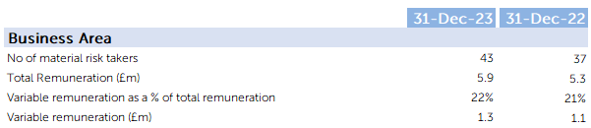

Remuneration of Staff by Business Area

The table below shows the breakdown of staff costs by Business area during 2023.

Additional disclosures on Remuneration are contained in the 2023 Annual Report and Financial Statements.

