Cambridge & Counties Bank Limited

Pillar 3 Disclosures

31 December 2024

Contents
Contents 2
1 Executive Summary 3
2 Introduction 4
3 Governance and Committees 6
4 Risk Management Objectives and Policies 8
5 Capital Resources 10
6 Remuneration 15

Executive Summary

Introduction
Cambridge & Counties Bank (CCB/ the Bank) is a UK bank that specialises in providing lending and deposit products for Small and Medium Enterprises (SMEs).

Established in June 2012, Cambridge & Counties Bank has a stable and supportive ownership structure being jointly owned by Trinity Hall, a college of the University of Cambridge, and Cambridgeshire County Council as Administering Authority of the Cambridgeshire Local Government Pension Fund.

The Bank is authorised by the Prudential Regulation Authority (PRA), regulated by the Financial Conduct Authority (FCA) and the PRA, and registered under the Financial Services Compensation Scheme.

The Bank does not have any subsidiaries.

Target Markets and Distribution Networks
Cambridge & Counties Bank provides lending products through a network of relationship managers who deal via business introducers as well as directly with customers. We seek to be straight forward and easy to deal with in our interactions with introducers and customers and deliver a banking experience that attracts and retains customers. The Bank delivers a range of savings accounts via the internet, post, and savings intermediaries.

We lend to experienced commercial and residential property investors as well as to owner occupied businesses to invest in their own commercial premises, secured on property. The Bank provides finance for businesses to acquire essential assets such as equipment, plant, machinery, or vehicles, using hire purchase and finance lease facilities. The Bank also provides finance for the purchase of classic cars using hire purchase and finance lease products.

The Bank remains focused on supporting SME customers in our chosen markets with an ambition to be the ‘Specialist SME Bank of Choice’. We continue to grow organically by meeting the needs of our customers and delivering a great service while modernising our infrastructure

The Bank’s lending is primarily funded by the acquisition of UK savings balances. We offer a range of deposit accounts that are available directly to business customers. These accounts are also available to retail customers through a network of Deposit Intermediaries. Business customers include broader organisations such as charities, clubs, societies, and associations.

Financial performance
For the year ended 31 December 2024, the Bank had operating income of £73.6m (2023: £76.4m) and reported profit before tax of £35.8m (2023: £40.9m). Total equity as of 31 December 2024 was £240m (2023: £215m).

The Bank employed an average of 243 FTE employees (2023: 225) during the year. Full details on the Bank’s financial results are reported in its statutory accounts which are published on its website (https://ccbank.co.uk/about-us/annualresults/ ).

Introduction

Legislative Framework
CCB follows the regulations in the PRA Rulebook for CRR firms. These regulations lay down uniform rules concerning general prudential requirements that CRR firms in the United Kingdom shall comply.

CCB throughout this document has followed the Pillar 3 disclosure requirements as set out for CRR firms and complies with the requirements in accordance with Article 433c of the Disclosure section of the PRA Rulebook.

Basel Committee on Banking Supervision (BCBS)
Most of the global banking and insurance regulations have been initiated or inspired by the work of the Basel Committee on Banking Supervision and its so-called “Basel regulations”. The three pillars of this regulation are as follows:

Pillar 1
The first pillar focuses on the determination of minimum capital requirements to support exposures to credit risk, counterparty credit risk, credit valuation adjustment risk and operational risk. (See Section 5)

Pillar 2
Pillar 2 addresses risks not covered in the Pillar 1 framework. To calculate its Pillar 2 capital requirements the Bank has performed a detailed assessment of the risks facing the Bank including the impact of a severe economic downturn. The Bank has calculated the amount of capital that it considers necessary to cover these risks within its Internal Capital Adequacy Assessment Process (ICAAP). The Bank’s ICAAP is reviewed and assessed by the PRA during its Supervisory Review and Evaluation Process.

Pillar 3
Pillar 3 complements Pillar 1 and Pillar 2 and sets out the disclosures that banks are required to make to promote market discipline through the external disclosure of its governance, capital resources, risk management objectives, remuneration and risk exposures. The Bank is required to publish its Pillar 3 report annually.

Purpose

The Pillar 3 disclosures on capital and risk management of 31 December 2024, have two principal purposes:
- To provide information on the policies and approach taken by CCB to risk management and the maintenance of its capital resources, including details of:
- The governance structure of the Bank; and
- Information concerning the Bank’s assets and capital resources.
- To meet the Pillar 3 regulatory disclosure requirements under the PRA rulebook.

The Pillar 3 disclosures are issued on an annual basis and should be read in conjunction with the Annual Report and Financial Statements for the year ended December 2024.

These disclosures have been reviewed by the Bank’s Audit Committee and approved by the Board. The disclosures are not subject to external audit, although some of the information within the disclosures also appears in the audited 2024 Financial Statements. The processes for preparing this disclosure are laid out in the Bank’s Pillar 3 Disclosures policy.

Publication
The disclosures are published on the Bank’s website: https://ccbank.co.uk/about-us/annualresults/

Regulatory changes
CCB has completed an impact analysis on the PRAs near final publications for Basel 3.1 and the consultation paper on Small Domestic Deposit Taker (SDDT) regime. In January 2025, the Bank applied, and has been confirmed, as a SDDT regime institution.

Policy, Verification, Sign Off and Contact Details
The Bank’s Pillar 3 disclosures have been verified and approved through internal governance procedures in line with the Bank’s Pillar 3 Disclosure Policy. The Board reviewed and approved the disclosures on 27 March 2025.

Cambridge & Counties Bank Limited
Charnwood Court
5B New Walk
Leicester
LE1 6TE

Telephone: 0344 225 3939
Email: Info@ccbank.co.uk
Web site: www.ccbank.co.uk

Governance and Committees

How the business is managed
Design and operation of a robust corporate governance framework is critical to meeting the needs of all the Bank’s stakeholders. The Bank has a well-established corporate governance structure, and the Board supports the principles of good corporate governance as set out in the UK Corporate Governance Code. Whilst the Bank is exempt from several of the provisions due to it not being a listed entity, and its overall size in terms of employee numbers, it has reviewed the requirements and will ensure that its governance processes continue to follow best practice. The Board believe that its existing governance processes are appropriate for the current size and structure of the Bank.

Structure of the Board and Board Committees

The Board has overall responsibility for the operations of the Bank and is comprised of four independent Non-Executive Directors and two Non-Executive Directors representing the interests of the owners. The Non-Executives are currently complemented by three Executive Director (ED) board members – the Chief Executive Officer, the Chief Financial Officer, and the Chief Risk Officer.
To ensure independence, and reduce the potential for conflict of interest, the sub-committees (excluding the Executive Committee) are each comprised entirely of Non-Executive Directors (NEDs), although individual EDs and others attend either as a matter of course or when requested to provide advice and guidance. A NED chairs each of the Board Committees except the Executive Committee which is chaired by the CEO.
The Bank changed its Chief Financial Officer during the year, with Andrea Hodgson resigning in September 2024 and Richard Hanrahan appointed as her successor.
Information about the Bank’s recruitment approach, including diversity, can also be found on the Bank’s website (https://ccbank.co.uk/about-us/careers/).
Detailed information on each of the above committees can be found in the 2024 Annual Report and Financial Statements.

The diagram below sets out the Bank’s Committee structure:

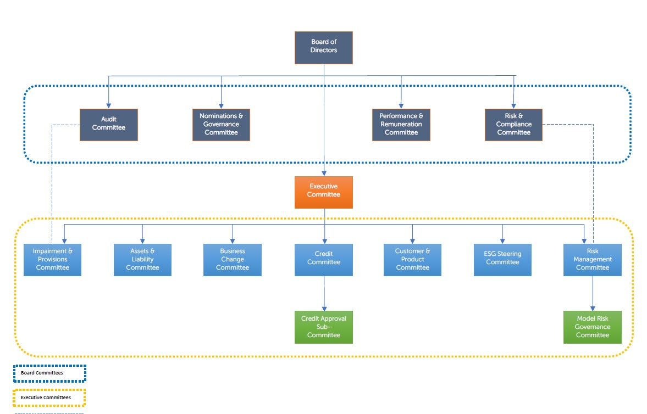

Risk Management Objectives and Policies

Introduction
The Enterprise Risk Management Framework (ERMF) clearly articulates the Bank’s approach to risk management, the risks the Bank is willing to take, and the inherent risks, in pursuit of its strategy.

The framework ensures that from the top down there is effective identification, assessment, control, management, reporting and escalation of risk, to operate within the appetite set by the Board; resulting in a transparent and strong risk culture. The key principles, tools, documentation, governance structure, roles, and responsibilities for risk management, across all risk categories, are confirmed in the framework along with the methodologies used to measure and monitor the ‘Risk Management Cycle’. In addition, the internal and external oversight, assurance, and approvals provided by Executive, Board, Second Line and Third Line control functions is confirmed.

A Risk and Control Self-Assessment programme and Top and Emerging risk reporting processes exist which supports monitoring and management of the Bank’s risk profile.

A forward-looking risk management approach is taken using quarterly stress testing and scenario analysis, feeding into the annual Internal Capital and Liquidity Adequacy Assessment processes (ICAAP and ILAAP) to ensure there is sufficient capital and liquidity to cover the risks to the Bank.

The following highlights the key elements of the Bank’s approach to risk management.
- Governance
The Chief Risk Officer has operational responsibility for the management of the bank’s ERMF. The Board has responsibility for setting the firm’s Risk Appetite and approval of this framework, as well as ongoing oversight, principally through the Board Risk and Compliance Committee.

- Three lines of defence model
The Bank adopts a ‘three lines of defence’ model to provide robust risk management, oversight and assurance with clear responsibilities established for all colleagues in relation to risk management, including Executive and Non-Executive responsibilities documented as applicable under the Senior Managers and Certification Regime. The Bank outsources its Internal Audit function to Deloitte LLP, who report directly into the Bank’s Audit Committee.

- Risk Appetite
The Risk Appetite articulates the amount and type of risks the Board is willing to take in pursuit of its strategy and objectives. The overall objective is to protect the Bank from unacceptable levels of risk while supporting and enabling overall business strategy (including the assessment of new business opportunities). The Bank’s Risk Appetite Statement outlines a mixture of qualitative and quantitative measures (Principal Risk Statements and Key Risk Indicators). The regular review of the Bank’s appetite for risk is facilitated and challenged by the Second line of Defence, driven by the recommendations of the appropriate executives and subject matter experts. The Bank’s performance against Risk Appetite is monitored via reporting to the Executive risk committees. This is summarised within the Chief Risk Officer Risk Report, which is presented to Risk Management Committee and bi-monthly to the Board Risk Committee. The periodic reporting shows status against each Key Risk Indicator (KRI) and overall rating, based on parameters set within the ERMF, using a Red/Amber/Yellow/Green (RAYG) scale and the expert judgement of the First and Second lines.

Risk profile
The Bank monitors its principal risks assessed against risk appetite statements. Each of the below risks are monitored within governance committee(s) and against defined risk appetites.

Principal risks:
- Strategic: The risk of having an insufficiently defined or flawed strategy that does not adapt to market and business developments and/or meet the requirements and expectations of our stakeholders.
- Environment, Social & Governance: The risk that the Bank doesn’t meet it’s environmental, social or governance objectives, which could cause an actual or a potential material negative impact on the Bank.
- Capital Adequacy: The risk that the Bank fails to hold sufficient capital to meet its regulatory obligations, support its growth plans or to absorb shocks.
- Liquidity & Funding: The risk of being unable to fund assets and meet obligations as they fall due, without incurring unacceptable losses.
- Market: The risk that changes in market rates negatively impact the earnings or market value of the Bank’s assets or liabilities.
- Credit: The risk that counterparties fail to meet, in a timely manner, the commitments into which they have entered. Credit Risk represents a principal risk for Bank.
- Legal, Compliance & Regulatory: The risk that non-compliance with laws or regulations could give rise to fines, litigation, sanctions, reputational damage, or financial loss.
- Financial crime: The risk that inadequate controls relating to financial crime could give rise to fines, litigation, sanctions, reputational damage, or financial loss.
- Operational: The risk that events arising from inadequate or failed internal processes, people, and systems, including Fraud, or from external events cause regulatory censure, reputational damage, financial loss, service disruption and/or customer detriment.
- Conduct: The risk that customers suffer loss or detriment due to failures at any stage of the customer journey, including inadequate product design, sales/marketing processes and operational delivery, data management and record keeping or the failure of its staff or key providers of services to act with integrity and treat the customers’ best interests as the highest priority.
- Financial model: The risk that the Bank incurs financial loss because of decisions that are principally based on the output of (internal) models, due to errors in the development, implementation, or use of such models.
- Operational Resilience: The risk that events arising from inadequately identified or managed Important Business Services cause regulatory censure, reputational damage, financial loss, service disruption and/or customer detriment. Operational resilience metrics are included within operational risk reporting.

Emerging risks:
The Bank regularly reassesses the key risks to which it is exposed including any which are emerging, within the environment in which it operates. The Bank’s emerging risks during 2024 are assessed to be:
- Global Macro-Economic outlook
- UK Macro-Economic outlook
- Delivery of 2024+ growth plan
- Climate change
- Cyber threat &
- Legal, Compliance & Regulatory

Additional disclosures on Risk management and the framework are included in the 2024 Annual Report and Financial Statements.

Capital Resources

Available Capital Resources
CCB manages its capital requirements in accordance with the PRA Rulebook for CRR firms. The Bank’s policy is to maintain a strong capital base to maintain investor and market confidence and to sustain the future development of the business. Throughout the period to 31 December 2024, the Bank maintained its capital resources at a level above the minimum capital adequacy requirements.
The Board manages its capital levels for both current and future activities and documents its risk appetite and capital requirements during stress scenarios as part of the ICAAP. The Bank presents regular reports on the current and forecast level of capital to the Executive Committee, ALCO, Risk & Compliance Committee and to the Board.
The Bank has elected to use the Standardised Approach for credit risk and the Basic Indicator Approach to operational risk. The Bank is not exposed to Market Risk.
Under PRA Rulebook, the Bank must set aside capital equal to 8% of its total risk weighted assets to cover its ‘Pillar 1’ capital requirements. The Bank must also set aside ‘Pillar 2’ capital to provide for additional risks. The ICAAP is the Bank’s internal assessment of its Pillar 2 capital requirements, which the PRA reviews and advises its expectations of the level of Pillar 2 capital to be held. The PRA will set Pillar 2A requirements for risks not captured under Pillar 1 capital requirements and it will set Pillar 2B requirements to meet potential shortfalls in capital that may occur in the future due to severe stress scenarios like economic downturns. Pillar 1 and Pillar 2A requirements are referred to as the Bank’s Total Capital Requirement (TCR). CCB maintains its capital base in excess of its TCR and PRA Buffer and has complied with all externally set capital requirements during 2024.
In addition to the TCR and PRA Buffer requirements, the Bank holds capital to meet the Capital Conservation Buffer (CCoB) and Countercyclical Capital Buffer (CCyB).

Key metrics
The table below presents CCBs key metric positions using its audited accounts as at 31 December 2024, with only items applicable to the Bank being shown.
As at 31 December 2024, the Bank maintained a strong regulatory capital position of £241m.
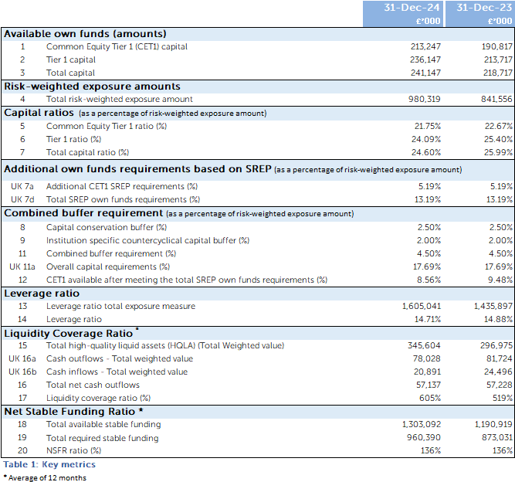

Overview of risk weighted exposures
The assets of the Bank are analysed by risk category and are assigned weightings which reflect the level of risk exposure under the Standardised Approach. The Bank’s credit risk consists of counterparty credit risk and all other credit risk, principally arising from its loans and advances to customers. The Bank uses Moody’s Investors Service as its nominated External Credit Assessment Institution (ECAI) for all standardised counterparty credit risk exposure classes. The Bank holds derivative instruments to manage its interest rate risk and does not hold a trading book. Derivatives follow the original exposure method for credit risk.

CCB is subject to Pillar 1 capital requirements related to the following risk items:
- credit risk
- operational risk;
- credit valuation adjustment risk;
- counterparty credit risk;
- prudent valuation on fair valued assets.
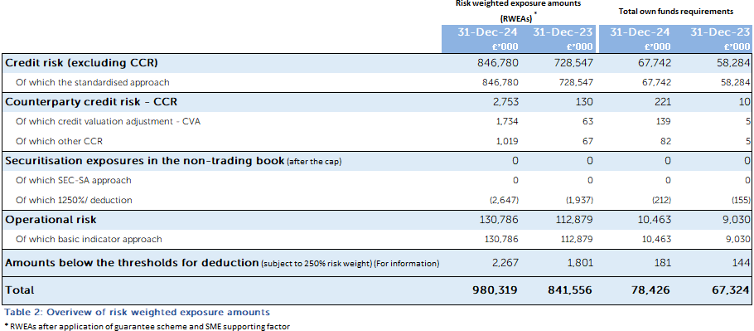

Credit risk exposure comprises of the following exposure classes for 31 December 2024 along with their exposure values and risk weighted exposures.

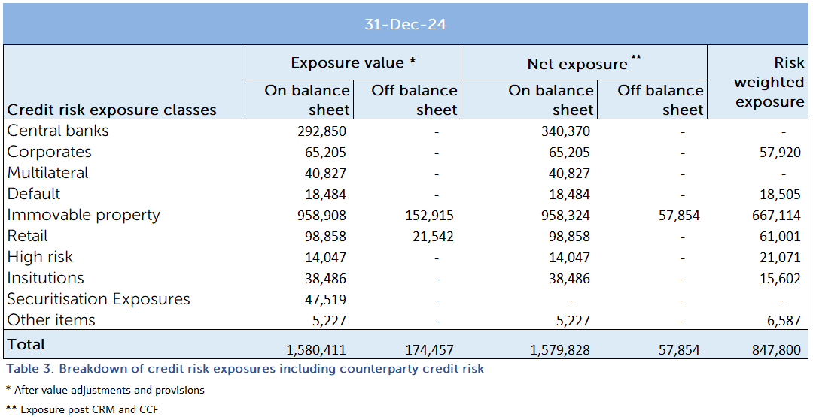

Composition of regulatory own funds
CCB holds CET1 capital consisting of Share capital and retained reserves. The regulatory CET1 capital is stated in the table after regulatory adjustments. The Bank also holds perpetual convertible loan notes eligible for AT1 and subordinated debt Tier 2 capital.

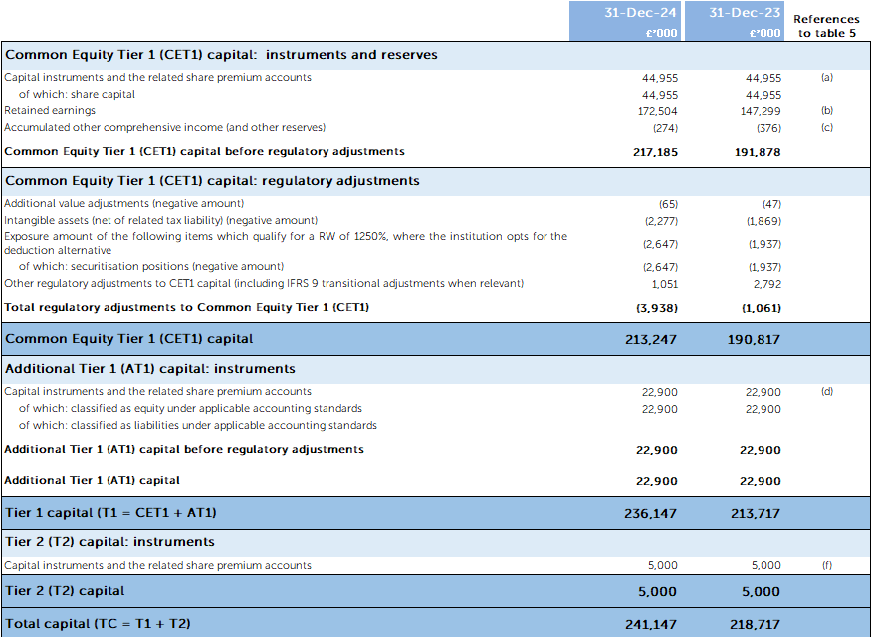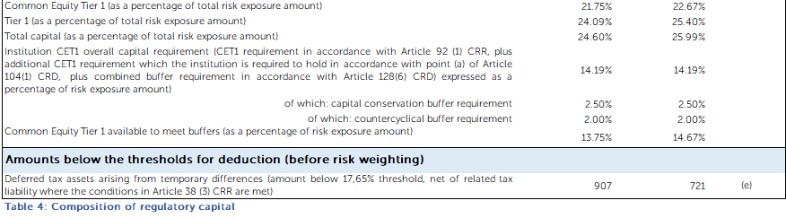

Reconciliation of Regulatory own funds to balance sheet in the audited Financial Statements
The following table shows comparison of items reported on the Banks Financial Statements and their corresponding scope for prudential regulatory reporting.

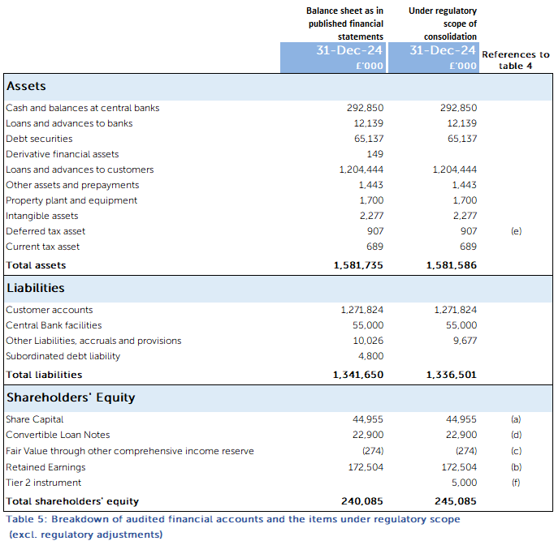

A reconciliation between Shareholders equity and Regulatory capital is shown below. The regulatory capital post adjustments are detailed in table 4.

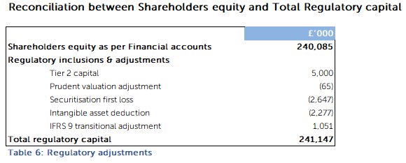

Remuneration
The Bank is classified as a “Proportionality Level 3” firm for the purposes of the disclosure of remuneration under the Bank of England Supervisory Statement SS2/17 and in compliance with the CRR on Remuneration Disclosure. The Bank has followed the regulator’s guidance on materiality and proportionality. The following disclosures meet the requirements for a Level 3 proportionality firm.
The Performance and Remuneration committee is chaired by Caroline Fawcett, Senior Independent Non-Executive Director, and is composed entirely of NEDs and met four times during 2024. In these meetings, the committee, in carrying out its responsibility for overseeing the performance and remuneration arrangements of the Bank, discussed the performance of all Executive Directors and the Chair.
During the year, the Committee reviewed and, where felt appropriate, approved the Bank’s profit share scheme and the sales and executive bonus schemes, upon agreed metrics and performance criteria, as well as upon advice from the Bank’s auditors and risk function. It also oversighted the annual pay review. The Committee has followed the rules under the Remuneration section of the PRA Rulebook.

Purpose & Objective
This policy describes the approach taken by Cambridge & Counties Bank in relation to its management of remuneration and describes how it complies with the relevant requirements of the Financial Conduct Authority (FCA) remuneration code (SYSC 19D) and the Prudential Regulation Authority (PRA) rulebook.

The Board of Cambridge & Counties Bank is committed to ensuring that the Bank has risk-focused remuneration policies, which are consistent with and promote effective risk management and do not expose the Bank to excessive risk.

The purpose of the Remuneration Policy is to clearly document the policies, practices and procedures linked to salary, compensation, and reward of employees. It is reviewed and approved annually by the Performance & Remuneration Committee.

Policy Scope
The policy relates to the remuneration of all employees; it covers both fixed and variable elements of pay and reward. Fixed elements are defined as salary, and allowances paid as a result of contractual obligations (e.g. car allowance, holiday pay, medical insurance, pension, and death in service). Variable elements consist of schemes designed to reward performance at both the corporate, team and individual level (e.g. Profit share, performance bonus schemes).

Specific remuneration rules may apply to board members and employees, who, because of their function, may have a material impact on the risk profile of the Bank, collectively referred to as “Material Risk Takers”.
The policy also covers fees paid to Non-Executive Directors.

The policy is to:
- Attract, develop, and retain high performing people with the ability, experience, and skill to deliver the business strategy and objectives;
- Offer competitive and market aligned remuneration packages in which fixed salaries are the significant component;
- Encourage and incentivise employees to create sustainable results, which are consistent with strategic goals and appropriate risk management, and align the interests of the Bank’s shareholders, customers, employees, and other key stakeholders; and
- Drive behaviour consistent with the Bank’s values so that employees do what is right for the customer, for colleagues, the Bank, and other stakeholders.
The remuneration policy and structure are consistent with the Bank’s long-term strategy including the overall business strategy, the risk strategy, and the Board’s risk appetite across all types of risks identified by the Bank

Governance
The Performance & Remuneration Committee is made up of Non-Executive Directors and shareholder representatives. The Chief Executive Officer, Chief People Officer and General Counsel are attendees. The full description of the Committee’s composition, tasks and authority are available in its Terms of Reference.

It is inbuilt to the remuneration review process that the Bank’s Risk and Compliance function is able to provide challenge to bonus and incentive payments where it feels individuals may be rewarded for poor risk behaviours; this is achieved through the Chief Risk Officer’s (CRO) report to the Performance & Remuneration Committee, inclusion of the CRO in calibration and approval meetings, and the membership of the Chair of Risk on the Performance & Remuneration Committee.

The Chief People Officer is responsible for the maintenance of this policy and ensures that Risk & Compliance Committee is made aware of any changes to enable the policy review schedule to be updated.

Reward outcomes in 2024
The Performance & Remuneration Committee has reviewed the business performance in 2024 and considered risk events in conjunction with the Board Risk & Compliance Committee, the affordability of paying variable pay, and the associated risk of low variable pay. After assessment of performance, the Committee has approved distribution of £3m variable pay award for 2024 (2023: £2.8m).

Remuneration
The 2024 Annual Report & Financial Accounts cover the remuneration policies for Executive Directors and Non-Executive Directors.

The Bank’s approach to annual salary reviews for all other employees is consistent across the business with consideration given to affordability, the level of experience, responsibility, individual performance, and salary level in comparable companies.

Pension and benefits provided to all employees are broadly in line with the policy for Executive Directors, although the commencement of benefits may be subject to longer periods of eligibility at the start of employment.

Consideration by the Directors of matters relating to Directors’ Remuneration

The Performance & Remuneration Committee engage Deloitte LLP (Deloitte) to provide independent advice on remuneration matters. Deloitte is a member of the Remuneration Consultants Group and, as such, voluntarily operates under the code of conduct in relation to executive remuneration consulting in the UK. Deloitte has provided independent advice on matters under consideration by the Performance & Remuneration Committee including compliance with regulations, advice on market trends and data, remuneration policy and implementation of remuneration arrangements, including support in remuneration arrangements for departing Executives. The Performance & Remuneration Committee is satisfied that the advice it has received has been objective and independent.

The total remuneration paid to the Bank’s highest paid Director for qualifying services as a director in the period from 1 January to 31 December 2024 is included in Note 11 to the Financial Statements.

Remuneration of Material Risk Takers
The table below sets out the remuneration of the Bank’s Material Risk Takers. These members of staff have been classified as ‘Code Staff’ as they have a material impact on the risk profile of the Bank. During the financial year 2024, 1 employee earned more than £1m.
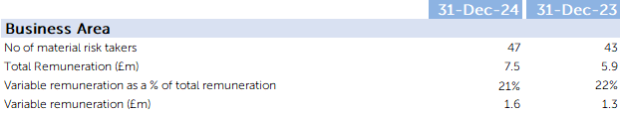

Remuneration of Staff by Business Area

The table below shows the breakdown of staff costs by Business area during 2024.

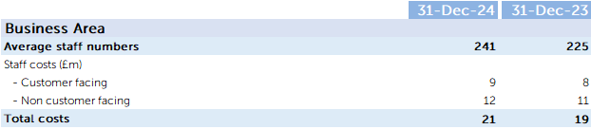

Additional disclosures on Remuneration are contained in the 2024 Annual Report and Financial Statements.

